# Gyroscope Test Plan

Test #1 – Adding Items

1. Fire up the application and you should see a window like this:

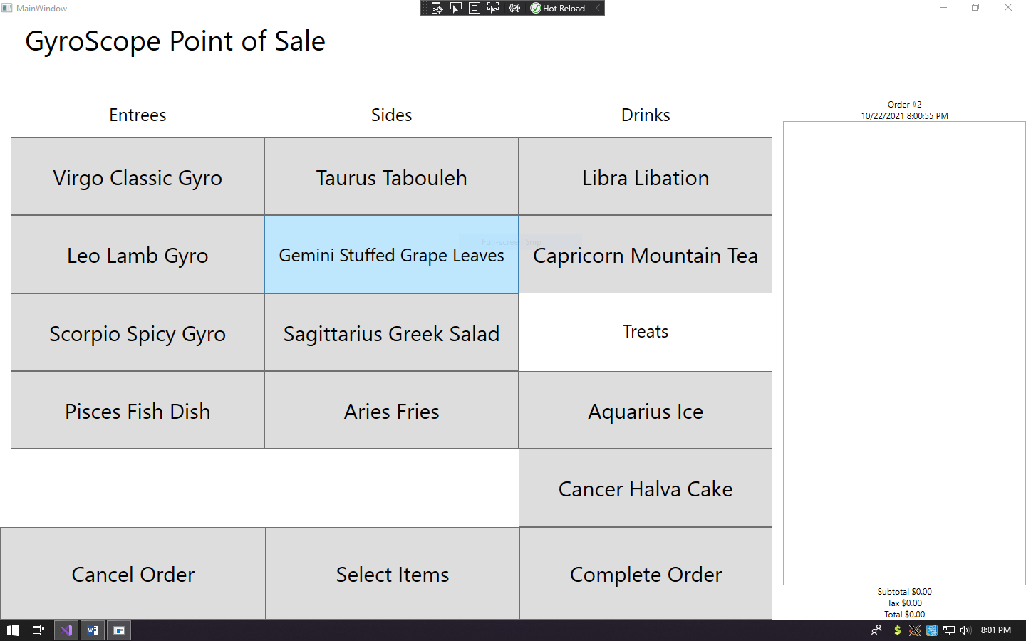

1. Click on the button the that says Virgo Classic Gyro and you should see a window like this:

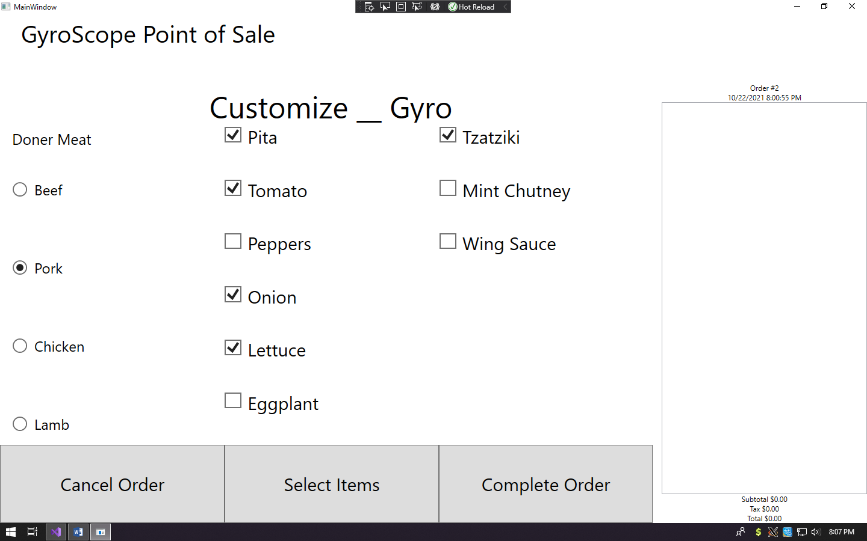

1. If the display was working correctly and you clicked the Complete Order button the list view on the right would look something like this:

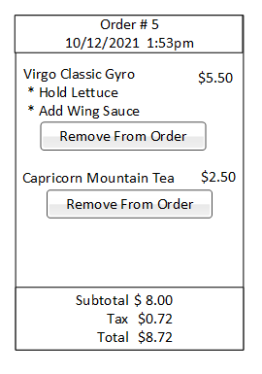

1. In this instant since it isn’t working click cancel order and you will see a display like this:
   1. Note the order number and the date and time have both changed

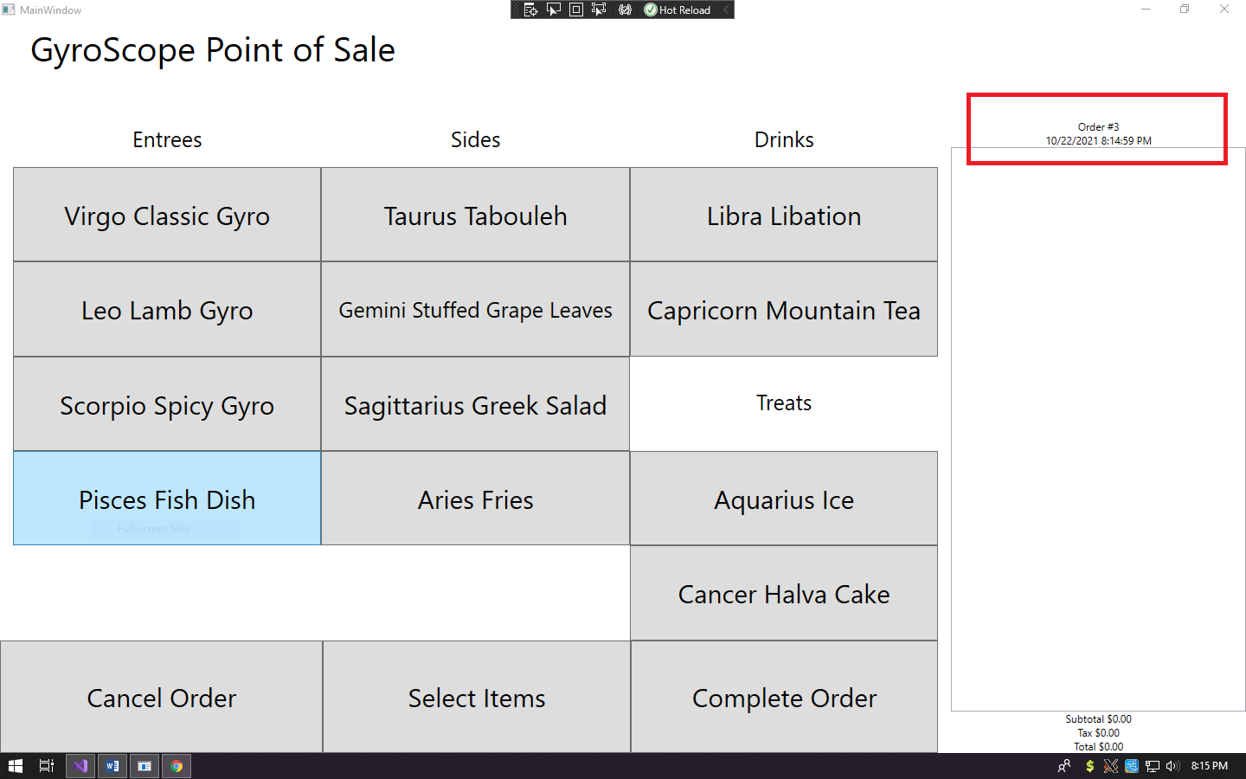

1. Lets just test another one of the button options since nothing is actually happening in the list view on the right
   1. Note I clicked Aquarius Ice since it’s different that the entrees

